**Finite Element Method**

STIFFNESS & DISPLACEMENT MATRIX OF A COMPOSITE PLANE STRESS PROBLEM (MATLAB CODE)

For any further communication:

[ayush.9924@gmail.com](mailto:ayush.9924@gmail.com) | +91 - 9874361217

[sahilgroversahil@gmail.com](mailto:sahilgroversahil@gmail.com) | +91 - 9434363574

**Authors:**

**AYUSH CHAPPARIA (11ME33028)**

**SAHIL GROVER (11ME33026)**

Contents

Problem Statement 2

Solution 2

Simulation1: 3

Assumptions 3

The Global Stiffness matrix 3

Nodal Displacements 4

Simulation 2: 5

Assumptions 5

Nodal Displacements: 5

Approach: 6

MATLAB CODE 7

Main File 7

Gauss Integration File 12

Gauss Simultaneous Linear Equation Solver 13

Introduction

# Problem Statement

A composite plane plate attached to the wall on left side as shown below undergoes a force of magnitude P on the top right corner.

Length

P

|  |  |
| --- | --- |
|  | Material 1 |
|  | Material 2  Width |
|  | Material 3 |
|  | Material 3 |
|  | Material 2 |
|  | Material 1 |

Perform an FEM analysis on the plate assuming the thickness of the plate is very small as compared to the width and length of the plate. Also, assume that the width of each strip is equal for all materials.

Inputs:

* Length, Width and Thickness of the plate
* The Modulus and Poisson’s ratio of all three materials
* Force (P)

# Solution

Assuming that the inputs are:

Length = 100 mm

Width = 60 mm

Thickness = 1 mm

Elasticity, Poisson’s ratio =

* Material 1 : 100 GPA, 0.25
* Material 2: 50 GPA, 0.3
* Material 3: 25 GPA, 0.35

Force = 5000 N

## Simulation1:

## Assumptions

No of Elements in X direction =5;

No of elements in Y direction = 6;

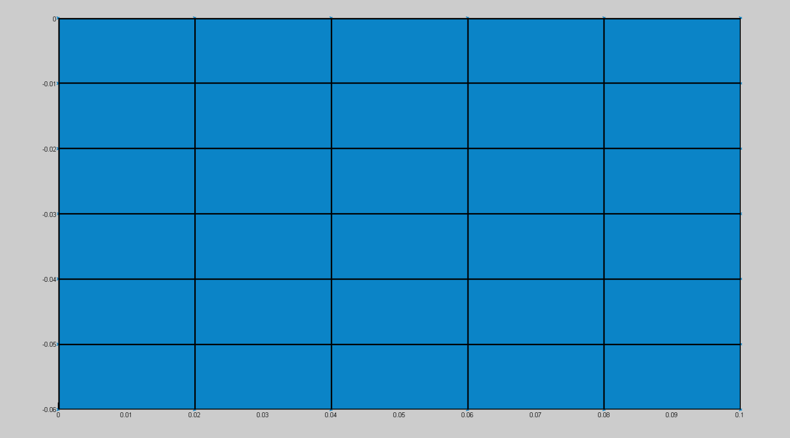

## The Global Stiffness matrix

After the code runs, the Global Stiffness Matrix Obtained is of order 84 X 84.

The Global Stiffness matrix obtained <https://goo.gl/JNZIJO> (the values in the file needs multiplication with “1e08” for real values). The file looks like (see below)



## Nodal Displacements

The nodal displacements obtained are:

X displacements =

1.0e-03 *

0 0.1971 0.3340 0.4392 0.5305 0.5929

0 0.0891 0.1783 0.2431 0.2697 0.2903

0 0.0219 0.0551 0.0736 0.0661 0.0889

0 0.0013 -0.0032 -0.0213 -0.0422 -0.0208

0 -0.0197 -0.0572 -0.0995 -0.1294 -0.1316

0 -0.0889 -0.1778 -0.2411 -0.2775 -0.2880

0 -0.2008 -0.3374 -0.4243 -0.4593 -0.4640

Y displacements =

0 -0.0002 -0.0005 -0.0008 -0.0013 -0.0019

0 -0.0002 -0.0004 -0.0008 -0.0013 -0.0019

0 -0.0001 -0.0004 -0.0008 -0.0013 -0.0018

0 -0.0002 -0.0004 -0.0008 -0.0013 -0.0017

0 -0.0002 -0.0004 -0.0008 -0.0012 -0.0016

0 -0.0002 -0.0005 -0.0008 -0.0012 -0.0016

0 -0.0002 -0.0005 -0.0008 -0.0012 -0.0016

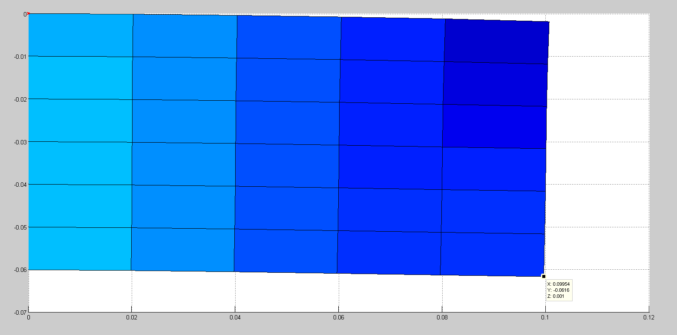

## Simulation 2:

## Assumptions

No of Elements in X direction =20;

No of elements in Y direction = 24;

## C:\Users\Ayush\Downloads\After meshing.pngNodal Displacements:

Theory

# Approach:

The following flow chart explains the approach used. Each step is coded in MATLAB such that the user would have full control over the inputs.

Using the Nodal displacement matrix, the elemental rigidity matrices and the elemental stiffness matrices the longitudinal, transversal and shear stresses at each element are calculated using Plane stress equations.

Once we have the Global stiffness matrix and the boundary conditions, we would have N systems of equations with N unknowns [displacements]. We apply the **GAUSSIAN ELIMINATION** to solve these equations and calculate the displacements of each node in 2 dimensions.

1. **External Forces**: The external forces provided by the user are applied on the respective nodes in the respective direction.
2. **Support**: Since the beam is a cantilever type the displacements of the nodes attached to the support will we zero.

Once the element stiffness matrices for each type of layer is calculated, they are assembled together to form the Global stiffness Matrix.

The following process is used for calculating the element stiffness matrices:

1. **Shape Functions** are calculated assuming 4-nodal elements.
2. Using the shape function and the rigidity matrix, stiffness matrix at a point is calculated.
3. **Gauss Quadrature** method is used for numerical integration in 2-D.

Using the material property of each layer (modulus of elasticity and poison’s ratio) the rigidity matrix is calculated for each layer.

Since we have three different types of layers we calculate the three rigidity matrices and store them in an array**: *rigidity*** *[3][3][3]*

Initially user is asked to define all the input variables. These inputs include:

1. **Beam definition**: Length, Width, Thickness, and modulus of elasticity and poison’s ratio of each layer.
2. **Mess Definition**: Number of elements in x and y direction.
3. **Load definition**: Magnitude and location of the applied load.

Appendix

# MATLAB CODE

Download the code files from https://goo.gl/rSDbZ2

## Main File

Name of the file -> FEM_final.m

clear all;

%% Defining variables

len = 100/1000; % in m

width = 60/1000; % in m

nx=5;

ny=6;

ndeg=2;

no_gauss=2;

thick=1/1000; % in m

elasticity=[100*1000000000,50*1000000000,25*1000000000]; % in PA

mu=[0.25,0.3,0.35];

force=-5000;

force_loc=(nx+1)*2;

% Defining variables ends

len_elem=len/nx;

width_elem=width/ny;

total_node=(nx+1)*(ny+1);

tot_free=(nx+1)*(ny+1)*ndeg;

free_elem=4*ndeg;

a=meshgrid(0:len_elem:len,1:ny+1)

b=transpose(meshgrid((0:width_elem:width)*-1,1:nx+1))

c=thick+zeros(ny+1,nx+1);

surf(a,b,c)

view(2);

hold on;

%*****************************************************************************************

%*****************************************************************************************

%% Initialize Rigidity Matrix

rigidity=zeros(3,3,3);

for i = 1 : 3

d=elasticity(i)/(1-mu(i)*mu(i));

rigidity(1,1,i)=d;

rigidity(1,2,i)=d*mu(i);

rigidity(1,3,i)=0;

rigidity(2,1,i)=d*mu(i);

rigidity(2,2,i)=d;

rigidity(2,3,i)=0;

rigidity(3,1,i)=0;

rigidity(3,2,i)=0;

rigidity(3,3,i)=d*(1-mu(i))/2;

end

%**********************************************************************************

%**********************************************************************************

xg=[0,len_elem,len_elem,0];

yg=[width_elem,width_elem,0,0];

zx=[-1,1,1,-1];

zy=[1,1,-1,-1];

sfd = zeros(4);

sfdz = zeros(4);

sfde = zeros(4);

stiff=zeros(free_elem,free_elem,3);

%% Developing a local element stiffness matrix using shape functions and concept of zi and eta.

for i = 1:no_gauss

for j = 1: no_gauss

[zeta,eta,hi,hj]=gauss_cau(i,j,no_gauss); %Refer gauss_cau function file to get a insight on how it works

for l = 1:4

zetaz=zeta*zx(l);

etaz=eta*zy(l);

sfd(l) = 0.25*(1+etaz)*(1+zetaz);

sfdz(l) = 0.25*(1+etaz)*zx(l);

sfde(l) = 0.25*(1+zetaz)*zy(l);

end

BB=zeros(3,free_elem);

DXZ=0;

DYZ=0;

DXE=0;

DYE=0;

for k=1:4

DXZ=DXZ+sfdz(k)*xg(k);

DYZ=DYZ+sfdz(k)*yg(k);

DXE=DXE+sfde(k)*xg(k);

DYE=DYE+sfde(k)*yg(k);

end

ZAC=DXZ*DYE-DYZ*DXE;

DXZI=DYE/ZAC;

DYZI=-DYZ/ZAC;

DXEI=-DXE/ZAC;

DYEI=DXZ/ZAC;

for ii=1:4;

k=2*(ii-1);

DNX=sfdz(ii)*DXZI+sfde(ii)*DYZI;

DNY=sfdz(ii)*DXEI+sfde(ii)*DYEI;

BB(1,k+1)=DNX;

BB(2,k+2)=DNY;

BB(3,k+1)=DNY;

BB(3,k+2)=DNX;

end

ASAT=zeros(free_elem,free_elem,3);

for ii =1:3

for m=1:free_elem;

for n=1:free_elem;

if n>=m

for l=1:3

for ki=1:3

ASAT(m,n,ii)=ASAT(m,n,ii)+BB(l,m)*rigidity(l,ki,ii)*BB(ki,n)*ZAC*thick;

end

end

end

end

end

end

for ii =1:3

for m=1:free_elem;

for n=1:free_elem;

if n>=m

stiff(m,n,ii)=stiff(m,n,ii)+ASAT(m,n,ii)*hi*hj;

end

end

end

end

end

end

for ii =1:3

for i=1:free_elem

for j=1:free_elem

stiff(j,i,ii)=stiff(i,j,ii);

end

end

end

% Stiffness Matrix Building Done

%% NOD = Matrix containing Nodes of each element

NOD=zeros(nx*ny,4);

for i = 1:nx*ny

nx1=nx+1;

nxi=floor((i-1)/nx);

for j= 1:2

NOD(i,j)=nx1*nxi+(i-nx*nxi)+j-1;

end

for j=3:4

NOD(i,j)=nx1*(nxi+1)+(i-nx*nxi)+4-j;

end

end

%% Assembling the local stifness Matrix on the global stiffness matrix

stiffo = zeros(tot_free,tot_free);

for i=1:nx*ny

if i<=nx*ny/6 || i>nx*ny*5/6 %condition1

for j=1:4

for k=1:4

stiffo(int64(NOD(i,j)*2-1),int64(NOD(i,k)*2-1)) = stiffo(int64(NOD(i,j)*2-1),int64(NOD(i,k)*2-1)) + stiff(j*2-1,k*2-1,1);

stiffo(int64(NOD(i,j)*2-1),int64(NOD(i,k)*2)) = stiffo(int64(NOD(i,j)*2-1),int64(NOD(i,k)*2)) + stiff(j*2-1,k*2,1);

stiffo(int64(NOD(i,j)*2),int64(NOD(i,k)*2-1)) = stiffo(int64(NOD(i,j)*2),int64(NOD(i,k)*2-1)) + stiff(j*2,k*2-1,1);

stiffo(int64(NOD(i,j)*2),int64(NOD(i,k)*2)) = stiffo(int64(NOD(i,j)*2),int64(NOD(i,k)*2)) + stiff(j*2,k*2,1);

end

end

elseif i<=nx*ny*1/3 || i>nx*ny*2/3 %condition2

for j=1:4

for k=1:4

stiffo(int64(NOD(i,j)*2-1),int64(NOD(i,k)*2-1)) = stiffo(int64(NOD(i,j)*2-1),int64(NOD(i,k)*2-1)) + stiff(j*2-1,k*2-1,2);

stiffo(int64(NOD(i,j)*2-1),int64(NOD(i,k)*2)) = stiffo(int64(NOD(i,j)*2-1),int64(NOD(i,k)*2)) + stiff(j*2-1,k*2,2);

stiffo(int64(NOD(i,j)*2),int64(NOD(i,k)*2-1)) = stiffo(int64(NOD(i,j)*2),int64(NOD(i,k)*2-1)) + stiff(j*2,k*2-1,2);

stiffo(int64(NOD(i,j)*2),int64(NOD(i,k)*2)) = stiffo(int64(NOD(i,j)*2),int64(NOD(i,k)*2)) + stiff(j*2,k*2,2);

end

end

else

for j=1:4

for k=1:4

stiffo(int64(NOD(i,j)*2-1),int64(NOD(i,k)*2-1)) = stiffo(int64(NOD(i,j)*2-1),int64(NOD(i,k)*2-1)) + stiff(j*2-1,k*2-1,3);

stiffo(int64(NOD(i,j)*2-1),int64(NOD(i,k)*2)) = stiffo(int64(NOD(i,j)*2-1),int64(NOD(i,k)*2)) + stiff(j*2-1,k*2,3);

stiffo(int64(NOD(i,j)*2),int64(NOD(i,k)*2-1)) = stiffo(int64(NOD(i,j)*2),int64(NOD(i,k)*2-1)) + stiff(j*2,k*2-1,3);

stiffo(int64(NOD(i,j)*2),int64(NOD(i,k)*2)) = stiffo(int64(NOD(i,j)*2),int64(NOD(i,k)*2)) + stiff(j*2,k*2,3);

end

end

end

end

% Assembling done

% Code for forming the halfband stiffness matrix

% NHB = (nx+3)*2;

% halfband_stiffo = zeros(tot_free,NHB);

% for j=1:NHB

% for i=1:tot_free

% if(j+i-1<=tot_free)

% halfband_stiffo(i,j) = stiffo(i,j+i-1);

% end

% end

% end

% halfband_stiffo

%% Developing Force matrix

pload=zeros(tot_free,1);

pload(force_loc,1)=force;

% Force matrix developed

%% Boundary conditions

for i = 1:ny+1

j=(i-1)*(nx+1)+1;

stiffo(j*2,j*2)=Inf;

stiffo(j*2-1,j*2-1)=Inf;

end

%Boundary fitting over

%% Calculating Displacements

x=zeros(tot_free,1);

u=zeros(tot_free,tot_free);

[x,u]=gausselim(stiffo,pload);

%Displacement Calculation done

%% Printing displacements

X_displacement = x(1:2:(length(x)-1));

Y_displacement = x(2:2:length(x));

X_displacement= transpose(reshape(X_displacement,(nx+1),(ny+1))) % Prints the X displacement of the nodes

Y_displacement= transpose(reshape(Y_displacement,(nx+1),(ny+1))) % Prints the Y displacement of the nodes

surf(a+X_displacement,b+Y_displacement,c,gradient(Y_displacement));

view(2);

%% Stress Generation Starts

for n=1:nx*ny

for j=1:4

for l = 1:4

zetaz=zx(j)*zx(l);

etaz=zy(j)*zy(l);

sfd(l) = 0.25*(1+etaz)*(1+zetaz);

sfdz(l) = 0.25*(1+etaz)*zx(l);

sfde(l) = 0.25*(1+zetaz)*zy(l);

end

BB=zeros(3,free_elem);

DXZ=0;

DYZ=0;

DXE=0;

DYE=0;

for k=1:4

DXZ=DXZ+sfdz(k)*xg(k);

DYZ=DYZ+sfdz(k)*yg(k);

DXE=DXE+sfde(k)*xg(k);

DYE=DYE+sfde(k)*yg(k);

end

% ZAC=DXZ*DYE-DYZ*DXE;

DXZI=DYE/ZAC;

DYZI=-DYZ/ZAC;

DXEI=-DXE/ZAC;

DYEI=DXZ/ZAC;

for ii=1:4;

k=2*(ii-1);

DNX=sfdz(ii)*DXZI+sfde(ii)*DYZI;

DNY=sfdz(ii)*DXEI+sfde(ii)*DYEI;

BB(1,k+1)=DNX;

BB(2,k+2)=DNY;

BB(3,k+1)=DNY;

BB(3,k+2)=DNX;

end

elemnode_disp=zeros(free_elem,1);

for ii=1:4

for l=1:2

k=(NOD(n,ii)-1)*ndeg+l;

m=(ii-1)*ndeg+l;

elemnode_disp(m,1)=x(k,1);

end

end

stress=zeros(3,1);

for m=1:3

for l =1:3

for k=1:free_elem

stress(m,1)=stress(m,1)+rigidity(m,l)*BB(l,k)*elemnode_disp(k,1)/2;

end

end

end

% fprintf('Elem node = %i , Node no = %i\n',n,j);

end

end

%Stress Generation ends

%% Code: if required to print global stiffness

% fileID = fopen('globalstiffnes.csv','w');

% for i= 1:tot_free

% fprintf(fileID,'%f,',stiffo(i,1:tot_free));

% fprintf(fileID,'\n');

% end

% fclose(fileID);

## Gauss Integration File

Filename -> gauss_cau.m

function [zeta,eta,hi,hj] = gauss_cau(I,J,no_gauss)

if no_gauss==2

hi=1;

hj=1;

if I==1

zeta = -0.577350269189626;

else

zeta = 0.577350269189626;

end

if J==1

eta = -0.577350269189626;

else

eta = 0.577350269189626;

end

else

if I==1

zeta=-0.774596669241483;

hi=5/9;

elseif I==2

zeta=0;

hi=8/9;

else

zeta=0.774596669241483;

hi=5/9;

end

if J==1

eta=-0.774596669241483;

hj=5/9;

elseif I==2

eta=0;

hj=8/9;

else

eta=0.774596669241483;

hj=5/9;

end

end

end

## Gauss Simultaneous Linear Equation Solver

Filename -> gausselim.m

function [x,U]=gausselim(A,b)

% function to perform gauss eliminination

%FORWARD ELIMINATION

n=length(b);

m=zeros(n,1);

x=zeros(n,1);

for k =1:n-1;

%compute the kth column of M

m(k+1:n) = A(k+1:n,k)/A(k,k);

%compute

%An=Mn*An-1;

%bn=Mn*bn-1;

for i=k+1:n

A(i, k+1:n) = A(i,k+1:n)-m(i)*A(k,k+1:n);

end;

b(k+1:n)=b(k+1:n)-b(k)*m(k+1:n);

end

U= triu(A);

%BACKWARD ELIMINATION

x(n)=b(n)/A(n,n);

for k =n-1:-1:1;

b(1:k)=b(1:k)-x(k+1)* U(1:k,k+1);

x(k)=b(k)/U(k,k);

end

end